**Application Description: Tool Rental Database Management System**

**Introduction**

The Tool Rental Database Management System is designed to streamline the process of renting, returning, and managing tools. This system is ideal for businesses that rent out tools and equipment, ensuring efficient operations, accurate record-keeping, and enhanced customer service. The system includes comprehensive features such as tool rental and return management, customer information tracking, and tool inventory control, all through a user-friendly interface.

Tool rental businesses typically involve a large number of tools and equipment, as well as frequent transactions with customers. Traditional manual management methods often lead to data errors, information loss, and low efficiency. The introduction of the Tool Rental Database Management System helps rental companies address these challenges, achieving more efficient, accurate, and intelligent management of rental business operations.

**Components:**

**Tables**

The database contains the following tables:

1. **dbo_Brands**: Stores information about different brands of tools.
2. **dbo_Customers**: Contains customer details such as name, contact information, etc.
3. **dbo_HandTool**: Stores details specific to hand tools.
4. **dbo_Payment**: Records payment transactions, including payment dates and amounts.
5. **dbo_PayMethod**: Details the different payment methods available.
6. **dbo_PowerTool**: Stores details specific to power tools.
7. **dbo_Rentals**: Records rental transactions, including rental dates and customer information.
8. **dbo_RentalsLine**: Contains line items for each rental transaction, detailing the tools rented.
9. **dbo_Tools**: General information about tools available for rental.

**Queries**

The database includes the following queries to fetch specific data:

1. **Order_Details**: Likely retrieves detailed information about each order, such as customer information, tools rented, and payment details.
2. **Order_Record**: Likely summarizes rental orders, including key details about each transaction.

**Forms**

Forms provide a user-friendly interface to interact with the database. The following forms are available:

1. **dbo_Customers**: For viewing and managing customer information.
2. **dbo_HandTool**: For managing hand tool details.
3. **dbo_Payment**: For viewing and recording payment transactions.
4. **dbo_PowerTool**: For managing power tool details.
5. **dbo_Rental_Start**: Likely used to initiate new rental transactions.
6. **dbo_RentalsLine**: For managing individual rental line items.
7. **dbo_Return**: To process the return of rented tools.
8. **dbo_Tools**: General form for tool information.
9. **dbo_Tools_info**: Possibly detailed information on tools.
10. **Index**: Login page.
11. **Welcome**: An introductory or home form for the database application.

**Reports**

Reports provide a formatted output of the database data. The following reports are available:

1. **Order_Details**: Likely provides a detailed report of each order, including customer and tool details.
2. **Order_Record**: Likely provides a summary report of rental transactions.
3. **OrderCheck**: Possibly used to verify orders and ensure accuracy.

**Key Features:**

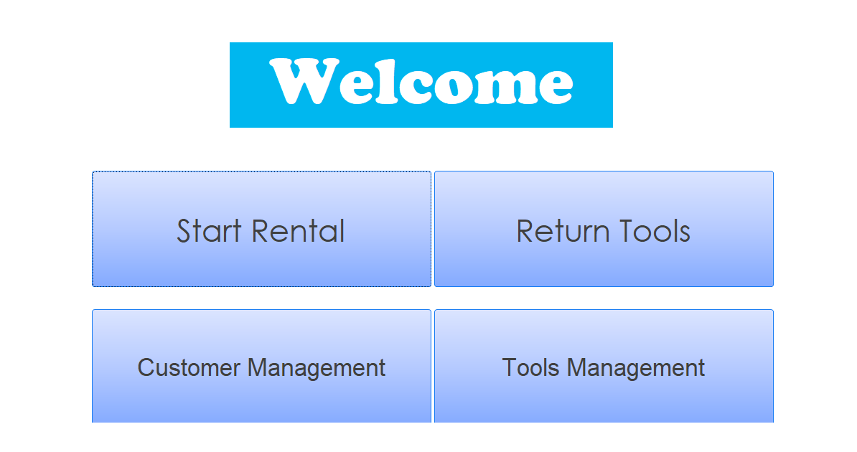

1. **Tool Rental:**

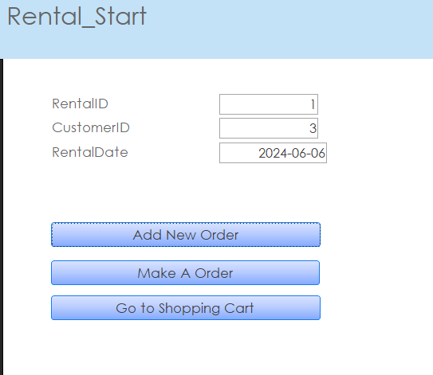

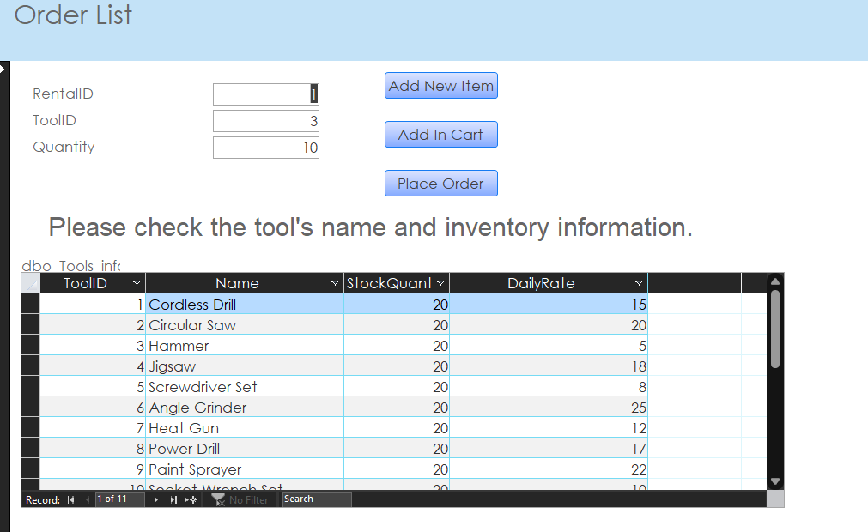

* + **Easy Processing:** The form simplifies the rental process by guiding users through customer selection, tool selection, and rental terms.
  + **Availability Check:** Real-time availability check to ensure tools are available for the desired rental period.
  + **Detailed Records:** Captures detailed rental information including rental dates, due dates, and rental rates.

1. **Tool Return:**

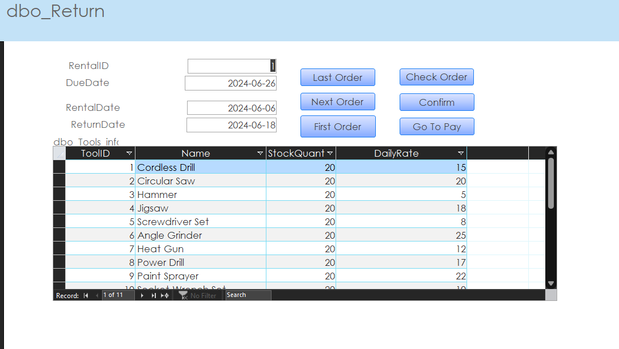

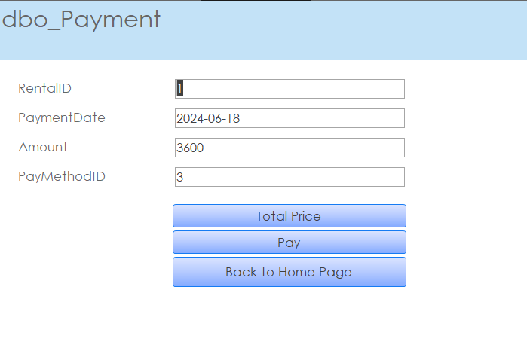

* + **Quick Processing:** The Return form streamlines the return process, allowing quick updates to rental records.
  + **Overdue Management:** Automatically calculates overdue charges based on return dates and overdue daily rates.
  + **Condition Reporting:** Option to report tool condition upon return to maintain inventory accuracy.

1. **Customer Management:**

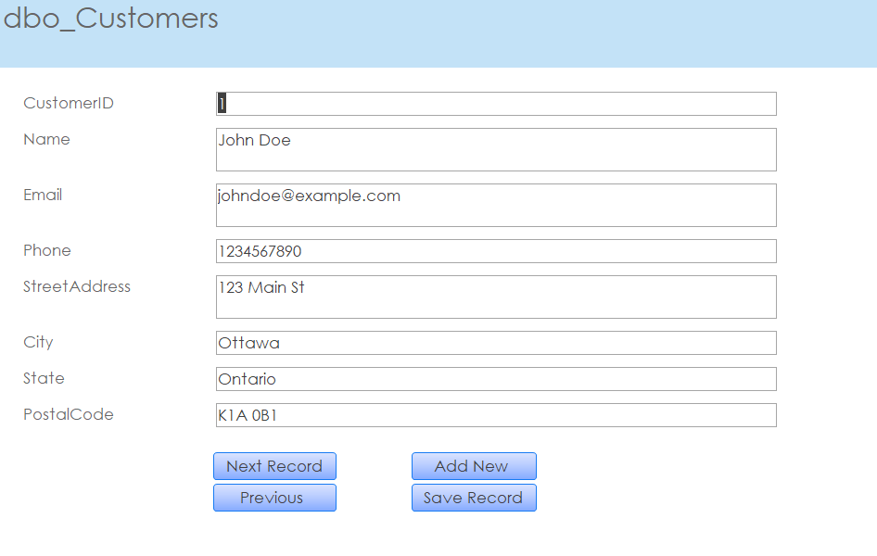

* + **Comprehensive Records:** The form allows for detailed customer records including contact details, rental history, and membership information.
  + **Efficient Updates:** Easy to add, edit, or delete customer information, ensuring the database remains up-to-date.
  + **Search Functionality:** Quick search capabilities to find customers based on various criteria.

1. **Tools Management:**

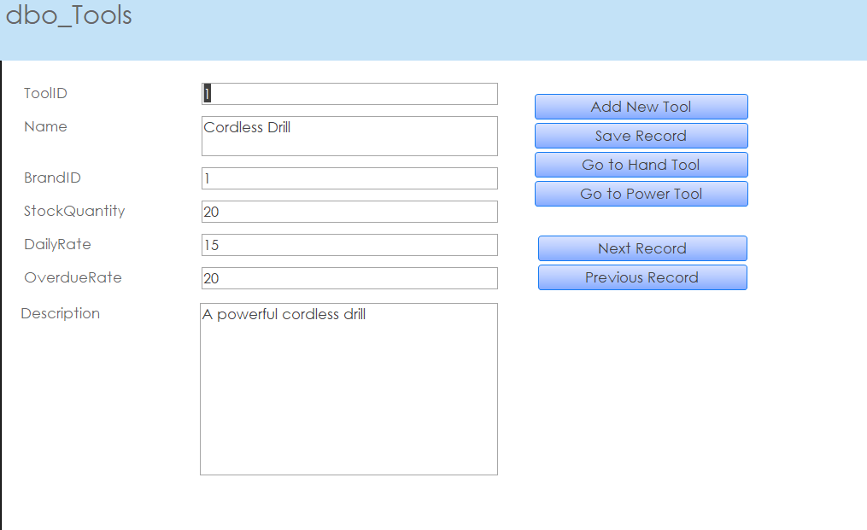

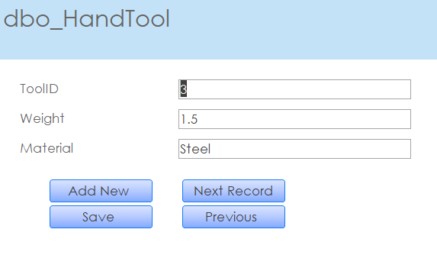

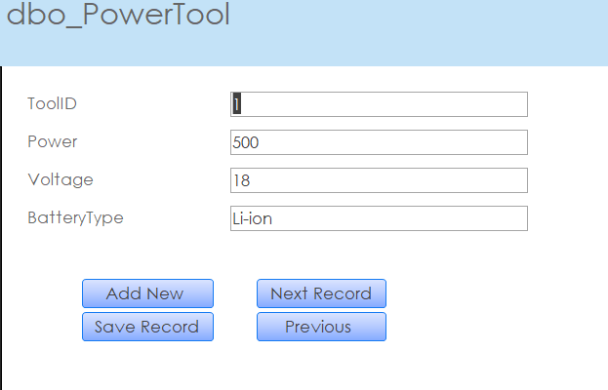

* + **Inventory Control:** The Tool form helps manage tool inventory, ensuring accurate records of tool conditions, availability, and locations.

**User Interface:** The system is designed with a user-friendly interface to enhance usability:

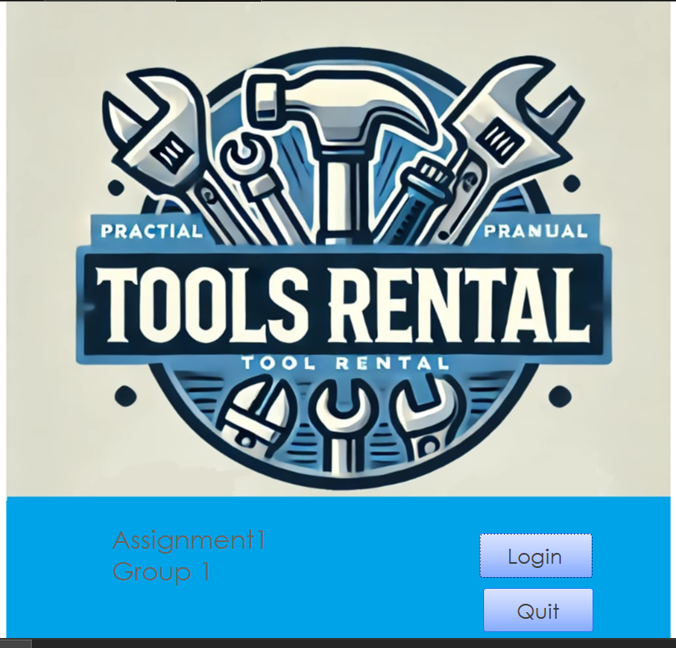

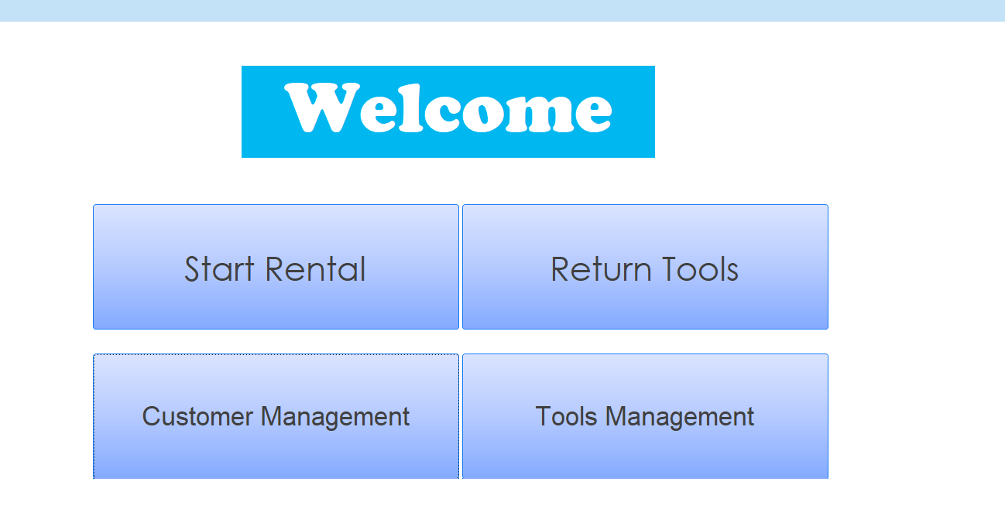

* **Main Navigation:** The home page provides quick access buttons for primary functions (Start Rental, Return Tools, Customer Management, Tools Management).
* **Intuitive Forms:** Forms are designed for easy data entry and navigation, with clear labels and prompts.
* **Real-time Updates:** Changes in tool availability and customer information are reflected immediately across the system.

**Security:**

* **User Authentication:** The system includes a secure login form to ensure only authorized users can access sensitive data.
* **Data Integrity:** Built-in validations and checks to maintain data integrity and prevent errors.

**Reporting:**

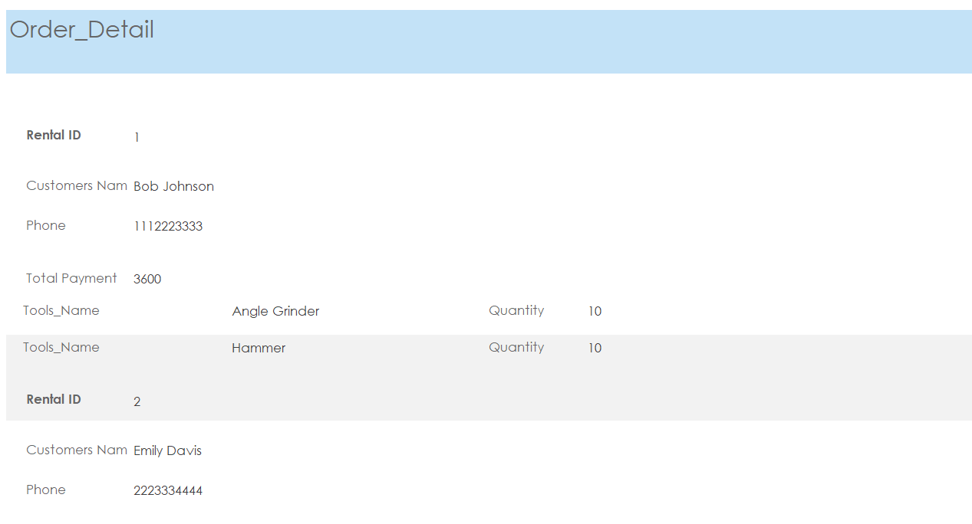

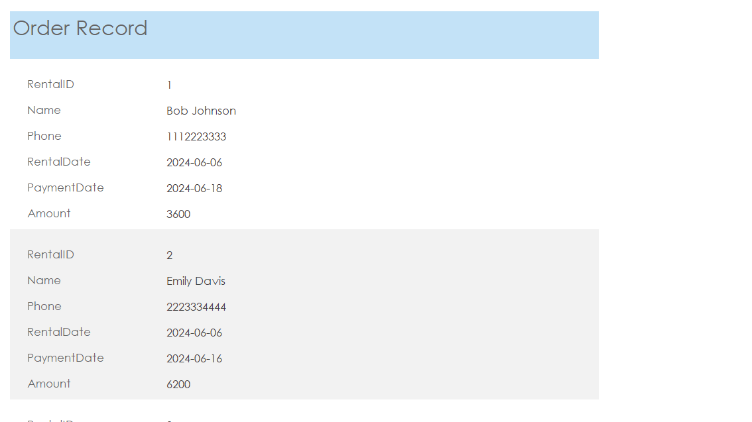

1. **Order_Details**: Likely provides a detailed report of each order, including customer and tool details.
2. **Order_Record**: Likely provides a summary report of rental transactions.

**Conclusion:** The Tool Rental Database Management System provides a robust and efficient solution for managing tool rentals, returns, and inventory. Its user-friendly design, comprehensive features, and secure operations make it an essential tool for any tool rental business. By automating routine tasks and providing real-time data access, the system enhances operational efficiency and improves customer satisfaction.